Partial / residual correlation: USDJPY and USDCHF
Method 07 / daily log returns / leave-currency-out USD factor / Alpari D1 full available history

Study setup
Logical pair: USDJPY , USDCHF
Broker symbols: USDJPY_i , USDCHF_i
Snapshot: 2026-11-03_majors_alpari_D1
Timeframe: D1
Matched return window: 1999-01-05 to 2026-11-02 (UTC bar dates)
Matched return count n: 7148
Dropped unfinished last bar dated 2026-11-03 UTC after a tick-volume check against the prior complete day.
USD-strength sign rule: minus log return when USD is the quote (EURUSD, GBPUSD, AUDUSD, NZDUSD); plus log return when USD is the base (USDJPY, USDCHF, USDCAD). EURGBP is never a constituent.
Control z constituents (5): EURUSD, GBPUSD, AUDUSD, NZDUSD, USDCAD
z_t = equal-weight mean of those USD-strength returns on the same day
Complete matched rows (Excel): USDJPY-USDCHF_Partial_D1.xlsx
Complete matched rows (HTML table): USDJPY-USDCHF_Partial_D1_data.html

Method carried forward
Partial / residual correlation regresses each matched daily log return of close, ln(close_t / close_t-1), on the same leave-currency-out USD strength factor z, then takes Pearson correlation of the two residual series. Quotes are not inverted. z is the equal-weight mean of USD-strength returns from other majors that do not share a non-USD currency with either leg; EURGBP is never a constituent. USD-strength is minus the log return when USD is the quote (EURUSD, GBPUSD, AUDUSD, NZDUSD) and plus the log return when USD is the base (USDJPY, USDCHF, USDCAD). OLS uses an intercept on each leg. rho_partial is symmetric under swap of the two symbols. It describes leftover linear co-movement after removing linear z; it is not a cause, not a lead, and not a trading signal. Daily rows are not independent and residuals are estimated, so the two-sided p-value and Fisher interval are secondary. Same-sample raw Pearson r is a side check only.

Regression on z
leg | intercept_a_or_c | slope_b_or_d | R2
USDJPY | 5.439e-05 | 0.21134335 | 0.03176343
USDCHF | -6.374e-05 | 0.69854518 | 0.30770341

Results
rho_partial: 0.365948
Two-sided p-value: 2.04095e-225
Approximate 95% Fisher interval: [0.345698, 0.385857]
Same-sample raw Pearson r: 0.398472
rho_partial minus r: -0.032524

Conclusion
Over 7148 matched daily rows for USDJPY and USDCHF after removing a leave-currency-out USD factor built from 5 constituents, rho_partial is 0.3659 (positive, weak residual linear link in this sample). Approximate 95% Fisher interval: [0.3457, 0.3859]. Same-sample raw Pearson r is 0.3985 (partial minus r = -0.0325). Leg R-squared on z: USDJPY=0.0318, USDCHF=0.3077. Two-sided p under the usual independent-pairs model is 2.041e-225; residuals are estimated and daily FX rows are linked, so treat p as secondary. This does not establish cause, lead-lag, or a lasting trading rule.

Charts
Daily closes
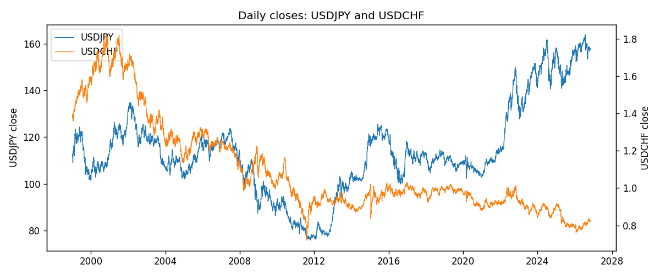
Log returns and control z
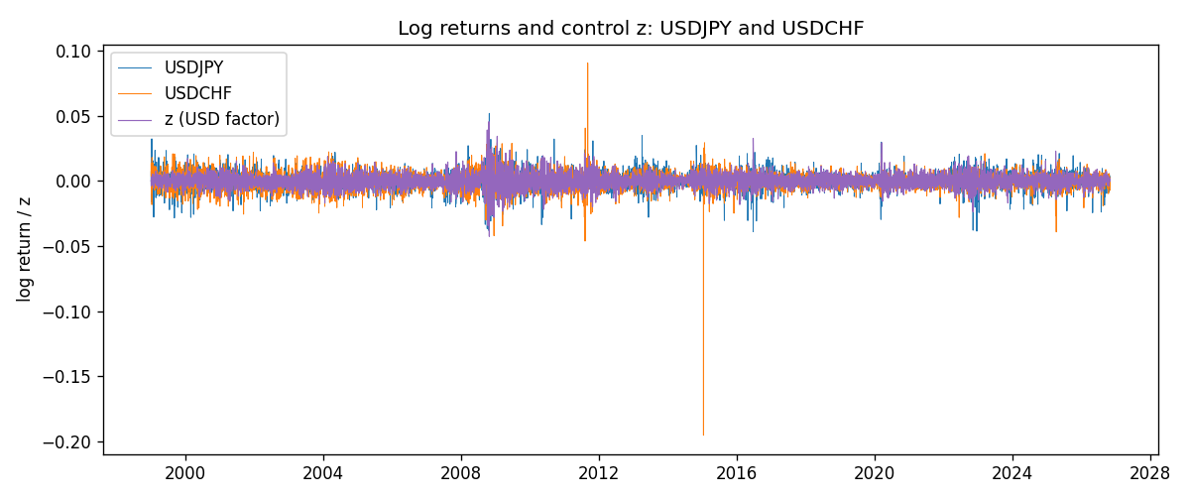
Residual scatter e_x vs e_y
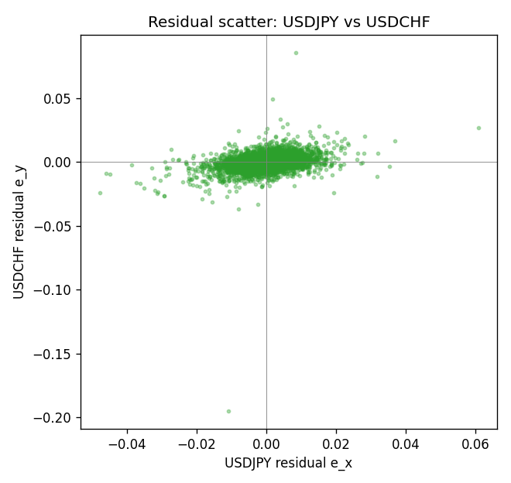

Data report
Every matched row that entered the partial correlation is stored in the sibling Excel workbook named USDJPY-USDCHF_Partial_D1.xlsx. That file is the complete data archive for redrawing charts. Embedding all rows as a Word table is impractical at this length; the Word file holds the column list, column summaries, and the first and last 15 matched rows.
Columns: time, USDJPY_open, USDCHF_open, USDJPY_high, USDCHF_high, USDJPY_low, USDCHF_low, USDJPY_close, USDCHF_close, USDJPY_tick_volume, USDCHF_tick_volume, USDJPY_spread, USDCHF_spread, USDJPY_real_volume, USDCHF_real_volume, USDJPY_log_return, USDCHF_log_return, usd_strength_EURUSD, usd_strength_GBPUSD, usd_strength_AUDUSD, usd_strength_NZDUSD, usd_strength_USDCAD, z, USDJPY_fitted, USDCHF_fitted, USDJPY_resid, USDCHF_resid
Column summaries (matched calculation rows)
column | count | mean | std | min | 25% | 50% | 75% | max
USDJPY_open | 7148 | 113.80278 | 19.266728 | 75.693 | 104.3275 | 110.969 | 120.725 | 163.824
USDCHF_open | 7148 | 1.0960885 | 0.25173228 | 0.72022 | 0.9203525 | 0.9894 | 1.2355 | 1.8219
USDJPY_high | 7148 | 114.30008 | 19.328348 | 76.001 | 104.8345 | 111.426 | 121.27175 | 163.978
USDCHF_high | 7148 | 1.101368 | 0.25346299 | 0.73305 | 0.9245 | 0.993025 | 1.240225 | 1.8313
USDJPY_low | 7148 | 113.28032 | 19.194266 | 75.402 | 103.8475 | 110.515 | 120.19 | 163.628
USDCHF_low | 7148 | 1.0909798 | 0.25015306 | 0.08565 | 0.9169075 | 0.98582 | 1.229425 | 1.8121
USDJPY_close | 7148 | 113.81631 | 19.281858 | 75.811 | 104.3175 | 110.995 | 120.7025 | 163.851
USDCHF_close | 7148 | 1.0960817 | 0.25162815 | 0.72025 | 0.92048 | 0.989445 | 1.2352 | 1.8217
USDJPY_tick_volume | 7148 | 106851.22 | 179762.89 | 197 | 10008.25 | 53482.5 | 93111.75 | 1803508
USDCHF_tick_volume | 7148 | 74666.538 | 113693.11 | 350 | 12884 | 40421 | 70666.5 | 858589
USDJPY_spread | 7148 | 20.16704 | 17.582453 | 0 | 6 | 11 | 30 | 50
USDCHF_spread | 7148 | 25.894096 | 24.64185 | 0 | 5 | 16 | 50 | 100
USDJPY_real_volume | 7148 | 3.4953653e+10 | 1.6133327e+11 | 0 | 0 | 0 | 0 | 3.8834203e+12
USDCHF_real_volume | 7148 | 2.3408849e+10 | 8.9348471e+10 | 0 | 0 | 0 | 0 | 1.9331921e+12
USDJPY_log_return | 7148 | 5.267e-05 | 0.00620906 | -0.03908203 | -0.00319392 | 0.00012736 | 0.00340928 | 0.05184024
USDCHF_log_return | 7148 | -6.945e-05 | 0.0065937 | -0.19545699 | -0.00334697 | 8.15e-05 | 0.00331954 | 0.09051364
usd_strength_EURUSD | 7148 | 2.16e-06 | 0.0058013 | -0.03433183 | -0.00325609 | -0 | 0.00324218 | 0.03123819
usd_strength_GBPUSD | 7148 | 1.992e-05 | 0.00564699 | -0.03112653 | -0.00318167 | -3.426e-05 | 0.0031217 | 0.08388241
usd_strength_AUDUSD | 7148 | -3.157e-05 | 0.00755018 | -0.0806166 | -0.00415111 | -0.00029168 | 0.00385014 | 0.08602525
usd_strength_NZDUSD | 7148 | -1.914e-05 | 0.00764519 | -0.05966839 | -0.004586 | -0.00023666 | 0.00424201 | 0.07027433
usd_strength_USDCAD | 7148 | -1.226e-05 | 0.00514518 | -0.03859748 | -0.00283513 | 4.873e-05 | 0.00272781 | 0.03436319
z | 7148 | -8.18e-06 | 0.00523601 | -0.04262743 | -0.00294072 | -8.876e-05 | 0.00295446 | 0.04548704
USDJPY_fitted | 7148 | 5.267e-05 | 0.0011066 | -0.00895463 | -0.00056711 | 3.564e-05 | 0.0006788 | 0.00966778
USDCHF_fitted | 7148 | -6.945e-05 | 0.00365759 | -0.02984093 | -0.00211796 | -0.00012574 | 0.00200009 | 0.03171101
USDJPY_resid | 7148 | -0 | 0.00610965 | -0.04784393 | -0.00305223 | 0.00014535 | 0.0031249 | 0.06079487
USDCHF_resid | 7148 | 0 | 0.00548625 | -0.19491149 | -0.00249103 | 0.00011396 | 0.00257661 | 0.0855434
First 15 matched rows (selected columns)
time | USDJPY_close | USDCHF_close | USDJPY_log_return | USDCHF_log_return | z | USDJPY_fitted | USDCHF_fitted | USDJPY_resid | USDCHF_resid
1999-01-05 | 111.92 | 1.3724 | -0.00017868311 | 0.0039424743 | 5.2993828e-05 | 6.5594254e-05 | -2.6719007e-05 | -0.00024427736 | 0.0039691933
1999-01-06 | 112.77 | 1.3912 | 0.0075660159 | 0.013605652 | -0.00041202005 | -3.2683336e-05 | -0.00035155221 | 0.0075986992 | 0.013957204
1999-01-07 | 111.33 | 1.3782 | -0.012851583 | -0.0093883841 | -0.0038300976 | -0.0007550713 | -0.0027392338 | -0.012096511 | -0.0066491503
1999-01-08 | 110.8 | 1.3935 | -0.0047719894 | 0.011040268 | 0.002997501 | 0.00068789627 | 0.0020301523 | -0.0054598857 | 0.0090101157
1999-01-11 | 109.02 | 1.4009 | -0.016195423 | 0.0052963193 | -0.0016474327 | -0.00029377958 | -0.0012145438 | -0.015901643 | 0.006510863
1999-01-12 | 112.6 | 1.3872 | 0.032310364 | -0.0098275602 | 0.0020039993 | 0.00047792629 | 0.0013361465 | 0.031832438 | -0.011163707
1999-01-13 | 113.52 | 1.3621 | 0.0081373171 | -0.018259701 | 0.00048561379 | 0.00015702561 | 0.00027548558 | 0.0079802915 | -0.018535186
1999-01-14 | 113.52 | 1.3588 | 0 | -0.0024256692 | 0.0015765174 | 0.00038758083 | 0.001037531 | -0.00038758083 | -0.0034632002
1999-01-15 | 114.15 | 1.3834 | 0.0055343401 | 0.01794228 | -3.2332106e-05 | 4.7561186e-05 | -8.6323027e-05 | 0.0054867789 | 0.018028603
1999-01-18 | 114.16 | 1.379 | 8.7600193e-05 | -0.0031856384 | -0.00058792814 | -6.986034e-05 | -0.00047443196 | 0.00015746053 | -0.0027112064
1999-01-19 | 113.52 | 1.3789 | -0.0056219403 | -7.2518946e-05 | -0.00160719 | -0.00028527455 | -0.0011864324 | -0.0053366658 | 0.0011139134
1999-01-20 | 112.91 | 1.3889 | -0.0053879917 | 0.0072259871 | -0.0006391056 | -8.0676356e-05 | -0.00051018173 | -0.0053073153 | 0.0077361688
1999-01-21 | 113.87 | 1.3836 | 0.0084664056 | -0.0038232689 | -0.003059912 | -0.00059229769 | -0.0022012244 | 0.0090587033 | -0.0016220445
1999-01-22 | 114.56 | 1.3834 | 0.0060412564 | -0.0001445609 | 0.0051079122 | 0.0011339176 | 0.0035043698 | 0.0049073388 | -0.0036489307
1999-01-25 | 113.72 | 1.3868 | -0.0073594164 | 0.0024546976 | 0.0020367833 | 0.00048485496 | 0.0013590475 | -0.0078442714 | 0.0010956501
Last 15 matched rows (selected columns)
time | USDJPY_close | USDCHF_close | USDJPY_log_return | USDCHF_log_return | z | USDJPY_fitted | USDCHF_fitted | USDJPY_resid | USDCHF_resid
2026-10-13 | 158.305 | 0.83244 | -0.0018932826 | -0.0024955621 | -0.0040513361 | -0.00080182858 | -0.0028937789 | -0.001091454 | 0.00039821682
2026-10-14 | 158.317 | 0.83489 | 7.5800166e-05 | 0.0029388325 | 0.0030886277 | 0.00070715527 | 0.0020938084 | -0.00063135511 | 0.00084502409
2026-10-15 | 158.024 | 0.82676 | -0.0018524319 | -0.0097855323 | -0.0026063762 | -0.00049644592 | -0.0018844092 | -0.001355986 | -0.0079011231
2026-10-16 | 157.964 | 0.82377 | -0.00037976126 | -0.0036230826 | -0.0036209284 | -0.00071086478 | -0.0025931197 | 0.00033110352 | -0.0010299629
2026-10-19 | 158.517 | 0.82677 | 0.0034946841 | 0.0036351779 | -0.00091435006 | -0.00013884744 | -0.00070245242 | 0.0036335316 | 0.0043376304
2026-10-20 | 158.16 | 0.8246 | -0.0022546642 | -0.0026281224 | -0.0037738178 | -0.00074317693 | -0.0026999198 | -0.0015114873 | 7.1797427e-05
2026-10-21 | 158.108 | 0.82427 | -0.00032883504 | -0.00040027413 | -0.001694611 | -0.00030375041 | -0.0012474999 | -2.5084636e-05 | 0.00084722581
2026-10-22 | 156.755 | 0.82032 | -0.0085942669 | -0.0048036381 | 0.0006622103 | 0.0001943481 | 0.00039884622 | -0.008788615 | -0.0052024843
2026-10-23 | 156.81 | 0.82497 | 0.00035080446 | 0.005652514 | -0.00039755608 | -2.9626473e-05 | -0.00034144848 | 0.00038043093 | 0.0059939625
2026-10-26 | 157.458 | 0.82649 | 0.0041238746 | 0.0018407959 | 0.0021729009 | 0.00051362252 | 0.0014541319 | 0.0036102521 | 0.00038666406
2026-10-27 | 157.894 | 0.82865 | 0.0027651658 | 0.0026100526 | 0.0015304276 | 0.00037784006 | 0.0010053352 | 0.0023873257 | 0.0016047174
2026-10-28 | 157.743 | 0.82781 | -0.00095679538 | -0.0010142111 | -0.00040091271 | -3.0335873e-05 | -0.00034379323 | -0.00092645951 | -0.00067041789
2026-10-29 | 157.683 | 0.82379 | -0.00038043789 | -0.0048680164 | -0.00049800933 | -5.0856598e-05 | -0.00041161961 | -0.00032958129 | -0.0044563968
2026-10-30 | 157.516 | 0.82438 | -0.0010596481 | 0.00071594559 | -0.00048694074 | -4.8517326e-05 | -0.0004038877 | -0.0010111308 | 0.0011198333
2026-11-02 | 157.933 | 0.81851 | 0.0026438521 | -0.0071459744 | 0.00098245807 | 0.00026203034 | 0.00062255376 | 0.0023818217 | -0.0077685282

